Identifying Underlying Needs
This tool will help you gain a deeper understanding of the underlying needs we all have but may not openly or knowingly express. Needs make no reference to any specific person doing any specific thing. Needs can also be referred to as values, desires or aspirations.

The Wheel of Universal Human Needs is a visual representation of a person’s overarching needs (outer ring of petals in dark gray) with words commonly used to describe them listed in the center. You may notice a speaker use these words when you are listening with empathy, or you may intuit these needs from what they are saying. Page 2 of this handout is designed to help you check your understanding of what’s important to the speaker.

The Wheel of Universal Human Needs
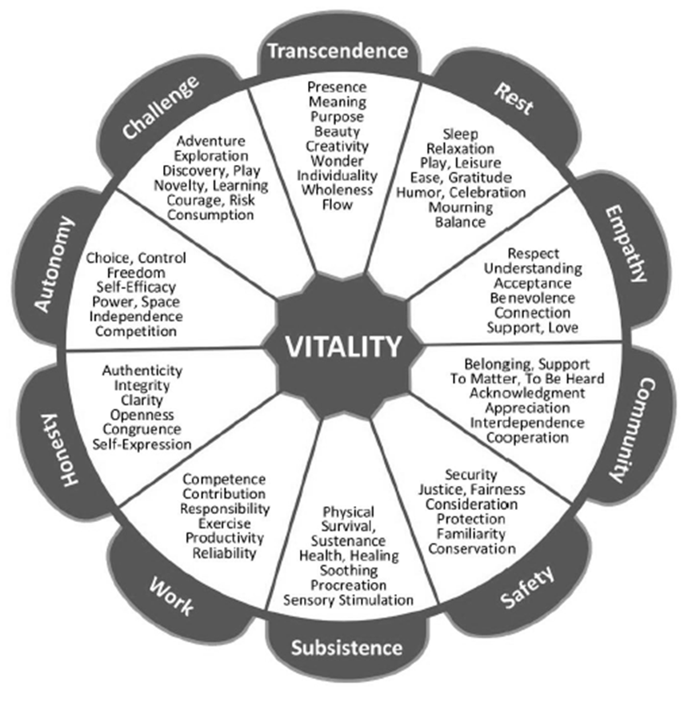
Inspired by the work of Manske J, Manske J. 2005. http://radicalcompassion.com. Accessed May 16, 2016.
Rosenberg M. Center for Nonviolent Communication. 2005. http://www.cnvc.org. Accessed May 16, 2016.
Max-Neef M, Ekins P, eds. Real-life Economics: Understanding Wealth Creation. London, UK: Routledge; 1992.
Adapted with the permission of the creator:
Jeff Brown, Certified Trainer with the Center for Nonviolent Communication (www.evolutionaryorganizations.org)
Expressing needs in natural language
The following list gives examples of how needs may be expressed in conversational language. As written, these questions might be used to check a listener’s understanding of a speaker’s needs. They can also be used as a springboard to further discussion. Think about a patient who starts asking questions about a mammogram in an angry voice. The clinician guesses that what’s important to her is autonomy. He might ask, “Would it help to know that you really have a choice in whether to undergo this test?” In this example, the clinician translates the word “autonomy” into the word “choice” and then uses it in conversation.

Underlying need | Possible questions to elicit underlying needs
AFFECTION | Do you want to be close?
APPRECIATION | Do you want to know that what you did is important?
AUTHENTICITY | Do you want to say what’s really in your heart?
AUTONOMY | Would you like to choose what to do?
CELEBRATION | Would you like to show how happy you feel?
COMPANIONSHIP | Would you like some company?
COMPASSION | Do you want to be heard about how special or hard this is for you?
COMPETENCE | Do you want to really know, or show me, that you can do it?
CONSISTENCY | Do you want to be able to count on this happening the same way each time?
CONTRIBUTION | Would you like to be able to help or share?
COOPERATION | Do you want everyone to work together as a team?
CREATIVITY | Do you want to explore what you can create?
EFFECTIVENESS | Do you want to be able to make things change?
EQUALITY | Do you want the same for everyone?
FREEDOM | Do you want to decide, by yourself, what is good for you?
HONESTY | Do you want to trust that what is said is true?
IDENTITY | Do you want to find out what you like?  Do you want to try different things and have the freedom to decide in another way if you didn’t feel comfortable with it?
INCLUSION | Would you like to be a part of what’s happening?
MOURNING | Do you want to show how sad you feel?
MUTUALITY | Do you want to share the same ideas or beliefs?
ORDER | Do you want to find things easily?  Do you want to know what’s going on around you?
PARTICIPATION | Do you want to have a say in what we do?
PEACE | Do you want quiet? …or calm? …or an easy time?
PURPOSE | Would you like something important to do?
RECREATION | Do you want to have any time without a schedule?
SECURITY | Do you want to know that you’re going to be ok?
STIMULATION | Are you looking for fun, or for something new to do?
Adapted with the permission of the creator:
Jeff Brown, Certified Trainer with the Center for Nonviolent Communication (www.evolutionaryorganizations.org)
(Originally created and conceived by Marshall Rosenberg)
The Center for Nonviolent Communication

With contributions from:
Tom Carlisi, Compassionate/Nonviolent Communication Coach & Trainer (www.carlisiandassociates.com)
Compassionate Communication Center of Ohio

Source: AMA. Practice transformation series: listening with empathy. 2016.

