Knowing your A1c
Hemoglobin A1c – A test to Measure Blood Sugar Control

What is it?
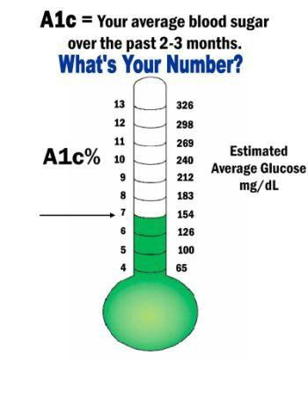
The hemoglobin A1C (or HbA1c) is a blood test that tells how well your blood sugar has been controlled over the past three months. It measures the amount of sugar that attaches to protein in your red blood cells. The greater the amount of sugar in your blood, the higher your A1C results will be. The A1C will be the best way to know if your average blood sugar is under control for a three-month period of time. It does not replace your daily testing, which can tell you if your blood sugar is too low or too high at that moment. Both tests are needed to know if your treatment plan is working.

What should my HbA1c results be?
Your test results will be reported with a “percent” sign, such as 7% or 10%. The A1c goal for many but not all people with diabetes is 7.0% or less but your goal may be different depending on your age and personal health history. You and your doctor should discuss what goal is best for you.
If your test result is under 7% or at your goal, your treatment plan is working and it is likely your blood sugar is under control. If your test result is higher than your goal, you may need to work with your health care team to change your treatment plan. Let them know if you skip your medicines occasionally.
Why should I have my A1C tested?
High blood sugars damage blood vessels and nerves, and over time this damage causes diabetes complications. As A1C results increase, your risk for eye disease, kidney disease, or nerve damage increase. The Diabetes Control and Complication Trial was a study of blood sugar control in people with type 1 diabetes. It showed that people who maintain an average blood sugar of 150 or lower (HbA1c <7%) are 60% less likely to develop complications such as kidney, eye and nerve damage compared to those whose blood sugars averaged above 200. We have learned from studies done in people with type 2 diabetes (UKPDS) that even small improvements in the A1C level reduce the risk of complications.

How often should I have this test done?
The American Diabetes Association recommends that people using insulin should have their A1C tested four times a year. When diabetes is controlled by pills or diet alone and the A1C is in target, twice a year may be enough. The test can be done every three months when your provider is trying to assess changes in your treatment plan.

Think of your HbA1c results like a bowling average. Even though each individual game is important, your bowling “average” tells you how well you are doing overall.

Example materials adapted from and courtesy of Medical Associates, Dubuque, Ia.

